Serial No:
Sessional I
Total Time: 60 minutes
Total Marks: 50
________________
Signature of Invigilator

CS301-Theory of Automata

Saturday, Sept 24, 2016
Course Instructor
Dr. Aftab Maroof, Dr Waseem Shehzad, Dr Labiba Fahad, Ms. Mehreen Alam

_____________________________________________ _____________________
Student Name Roll No Section Signature

DO NOT OPEN THE QUESTION BOOK OR START UNTIL INSTRUCTED.
Instructions:
- In all questions, use the algorithms studied in the class and show all steps to get full credit.
- Understanding the question paper is also part of the exam, so do not ask any clarification.
- The question paper is printed on both sides of the pages.
- Attempt all questions on the same sheets/pages and within the space provided with each question. You may lose marks if you write in extra space.
- Make sure that this question paper contains eight (08) pages including title page. Be brief, smart and efficient!
- Use permanent ink pens only. Any part done using soft pencil will not be marked and cannot be claimed for rechecking.

Question | 1 | 2 | 3 | 4 | 5 | 6 | Total
Marks Obtained
Total  Marks | 5 | 10 | 10 | 5 | 10 | 10 | 50

Vetted By: _____________________________Vetter Signature: _____________________

Q1. [5 pts] Give recursive definition of language defined over alphabet Σ = {a, b}, having all strings not ending with aa or bb.

Q2. [5+5 =10 pts]Write regular expression for each of the following language defined over alphabet Σ ={a, b}
- Language of strings not having bb or aa at any place

- Language of all strings having number of b’s in multiples of 2

Q3. [10 pts] Convert the following GTG to a regular expression. Show all the steps.

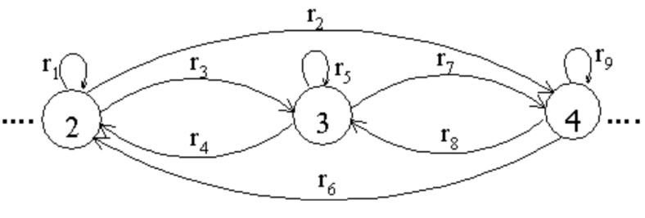

Q4. [5 pts] Convert the regular expression ( (ab)*b )* to NFA.

Q5. [10 pts] Convert the following NFA to the corresponding DFA. Show the resultant transition table and the state diagram.
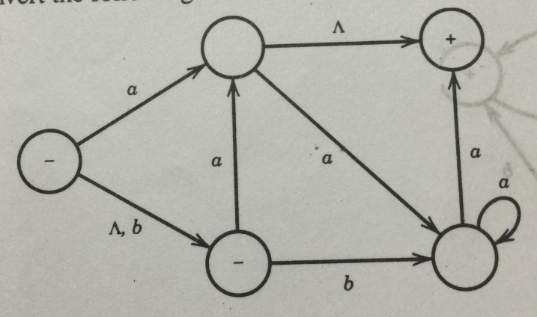

Q6. [ 10pts ] Minimize the following (copy diagram from the book) DFA. Show the resultant state diagram and transition table.
